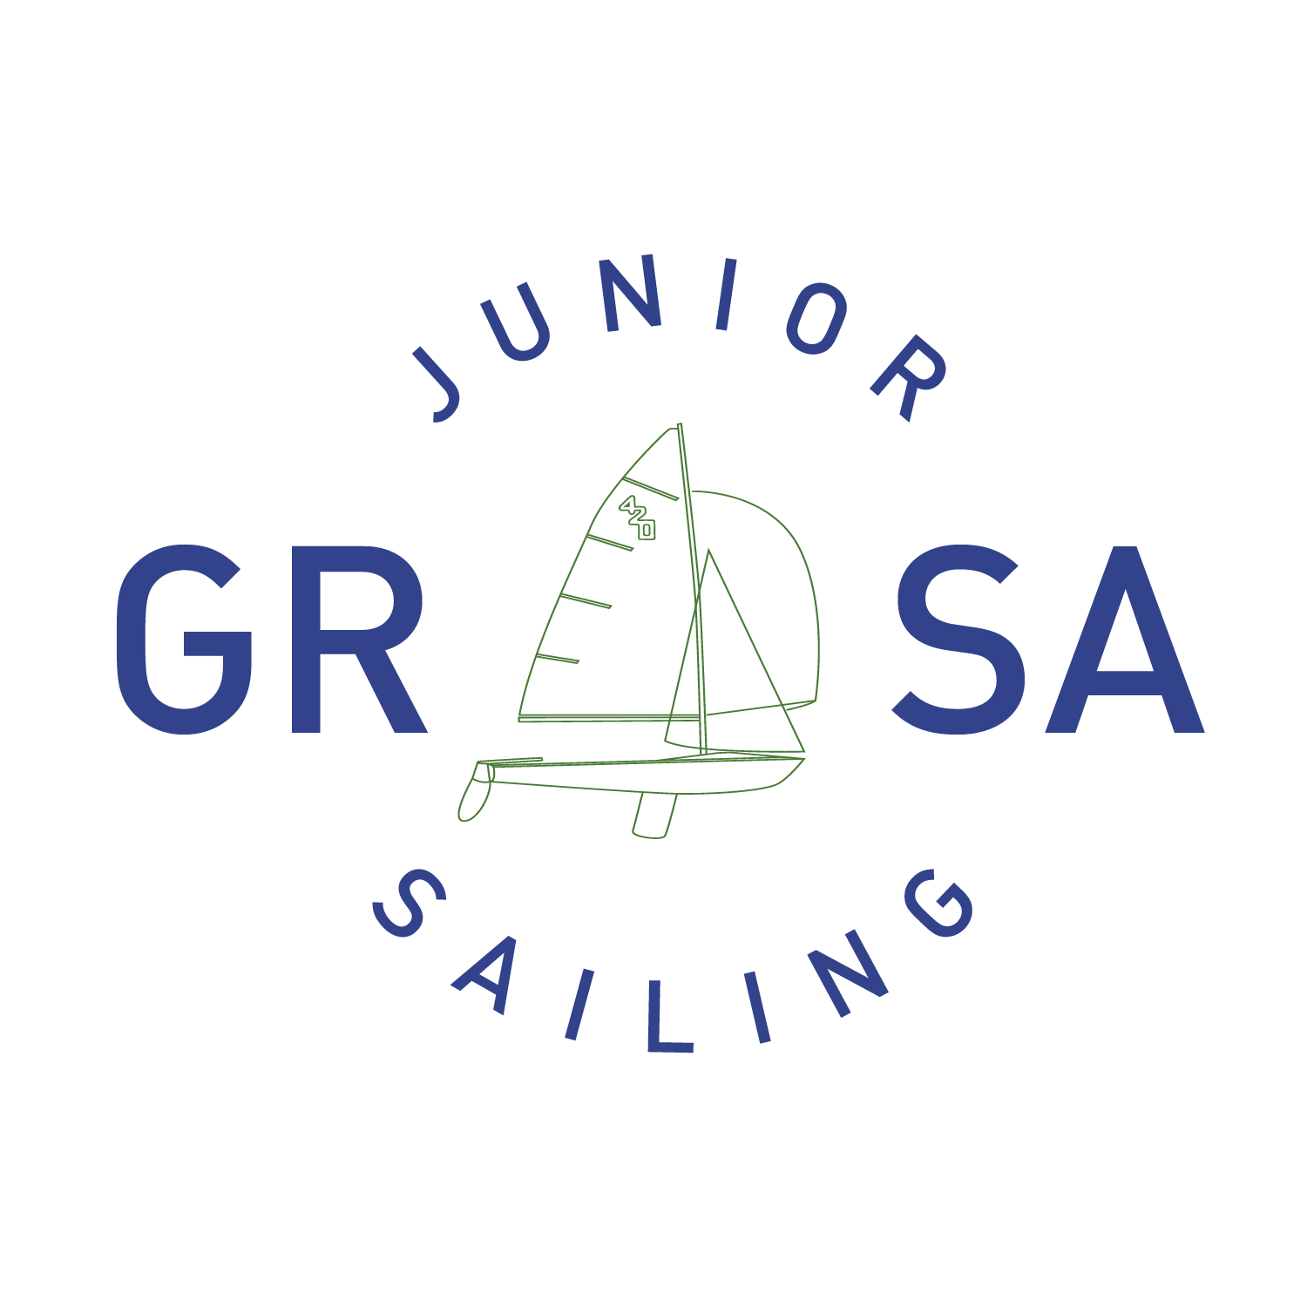
Student Guide and Parent Handbook
GRSA Physical Address: 4301Woolridge Rd, Midlothian, VA 23112

Objectives of the Program:
- Promote the sport of sailing and provide outreach to the surrounding community.
- Provide an invaluable resource to the growth of the club through fostering the sport through learn to sail programs.
- Instill the love of sailing to our students and make every sailor we work with a better sailor.
The Greater Richmond Sailing Association is a membership organization whose purpose is to promote sailing in the Richmond, Virginia area.

The Staff:
Most Sail Programs staff members are certified by either US Sailing or the American Sailing Association. This means they have been trained and are backed by one of the premiere sailing organizations in the United States. Any staff member over the age of 18 has completed a background check and is a certified coach through Chesterfield County. There will be adequate instructor staffing to assure an optimum student/teacher ratio. Overall supervision of the program will be by the Sail Camp Director, Lexi Cookson. If you need to contact her directly please email at grsa.sailprograms@gmail.com or call/text (804) 475-3896.

Facility, Boats, and Requirements:
We are located southwest of Richmond on the Swift Creek Reservoir at 4301 Woolridge Rd. Mosley, VA 23112. The course will be held in the main pavilion, which is located next to the flag pole. Please do not park on the entrance road that is reserved for access to trailered boats or in the traffic circle surrounding the flag pole. There is a 3.5 mph speed limit on club grounds that is strictly enforced, please DO NOT SPEED! GRSA does have restrooms on site. A kitchen is also available with refrigerators and a microwave for storing and heating lunch items. GRSA does not offer vending machines or food for sale so please plan on bringing your own lunch and snacks. Water will be available for campers, with staff refilling water bottles on demand. The classroom facility at GRSA is an open air pavilion with picnic bench seating. We do not have an air conditioned, indoor facility. The GRSA entrance uses an automated gate system with a key code entry. For safety concerns, we will only have the gate open from 8:00am-8:45am and then from 3:30pm-4:15pm to prevent outside traffic from entering. Parents will still have full access to their students during these hours but will need to call the club landline at (804) 739-9054 or our camp director at (804) 475-3896 to have the gate opened for the club. Please do not bring pets, including dogs, during drop off, pick up, or on Fridays. GRSA does not allow pets on site and this will be strictly enforced.
For our Junior Campers (ages 8-12) we provide a fleet of Optimist dinghies. This is a 7’ single handed boat. This means that students in this class will be sailing their own boat! Opti’s are considered the standard learn to sail dinghy for students around the world. For our Teen Campers (ages 13-17) we will be utilizing our fleet of International 420’s. They are named after their length of 4.2 meters (13’9’’) and are a two sailed, double handed boat. Students in this class will be paired with another student to master working both the mainsail and jib. For our Level III program we will be using our newest fleet of boats; the Flying Scots! The Flying Scot is a 19’ day sailor that provides a comfortable, stable learning platform. Each boat requires a minimum of two to operate. During the course you will be paired with up to three other students on these boats.
Each student is required to provide their own U.S. Coast Guard approved Type III life preserver, closed toes shoes, and be able to swim. Students will not be allowed to participate if they fail to meet these requirements. For specific questions about these requirements please contact Lexi Cookson at sailprograms@grsa.org.

What to bring to the course:
1. Life jackets (PFDs)- Students are required to bring their own USCG-approved life jacket each day and will be required to wear them at all times when on the water. If at all possible, please do not come with the orange, collar life jackets. While they are effective, it is difficult to maneuver in small sailboats with this PFD, and it is also very uncomfortable for longer periods of time. Students will be required to wear their life jackets whenever on the dock, swimming and while sailing. This is for the safety of every student.
2. Clothing - Students should dress in comfortable clothes that can get wet. Some prefer to wear bathing suits when sailing. There is no standard ‘sailing’ outfit. Athletic type clothing that is comfortable and allows for movement is a suggestion. Students will get wet so please keep this in mind. Please watch the weather leading up to the course and dress appropriately. If it looks to be a little cooler, bring a jacket or pants to put on. A towel and complete change of clothes are also recommended.
3. Shoes - Required at all times! Closed toed shoes are a must when learning to sail. Toes can get banged and bumped easily and protection is needed. Flip flops will not be permitted to go sailing in! Crocs, Keens, Water Shoes, or old tennis shoes are the best options. Please make sure all shoes have light soles that will not mark up the deck of the boats.
4. Sun Protection - Sunscreen is a must. Hats, visors or sunglasses are highly recommended.
5. Plastic Water Bottle – We recommend the athletic type bottles found at sporting goods stores or half-liter plastic bottled water containers, which have worked well at past sessions. Students are encouraged to drink plenty of water on hot days, both on and off the water. We will have plenty of water to refill throughout the day to keep everyone hydrated.
6. Lunches - Students should bring their own lunch. Refrigerators and microwaves are on site for use.
7. Completed Forms-make sure to bring your completed Risk Form and Student Registration Form with you to class the first morning. These forms should have been emailed to you after you registered. They can also be found on our website under Sail Camp.

Optional items: Some students opt to buy sailing gloves to protect their hands while sailing and handling line. These are not necessary but something you may like to have if you have sensitive hands. Zinc is another optional item that may be helpful if you are sensitive to long exposure to the sun.

Daily Routine:
Upon arrival to GRSA, Junior Sailors should sign in on the check in sheet. They should then put away their belongings (ex. Lunch in the refrigerator) and wait for class to start. The instructors will have the day outlined on the board so each student can know what to expect for that day. The first activity for Monday morning will be the swim test. Please have you child prepared for what they should expect to complete this test. The swim test will include wading into the lake without wearing their lifejacket, swimming 50 yards unassisted, having an instructor hand them a life jacket, putting on the lifejacket while in the water, and then wading back out of the lake.
The camp will begin promptly at 8:30am. Please attempt to arrive no earlier than 15 minutes before the camp as the site may not be staffed to watch your child. In order to ensure safety and establish a plan for the day, sailors will typically meet with the instructor to start their lesson and discuss the skills to be learned and possible activities for the day before going out on the water This is an important component of any safe, effective and efficient sailing camp. We will try to keep junior sailors on the water as much as possible, but not at the expense of focused objectives and safety.
The instructors will close the lesson with a brief review and discussion of the day’s events where each sailor can ask questions and reflect on how to improve. Junior Sailors shall not leave until all the equipment has been washed and stored properly. This includes sails and hulls. Junior Sailors must wait for the instructor to dismiss them. We will make every attempt to have your child ready for pick up at 4:00pm. Please ensure that your child is picked up within 15 minutes of their scheduled class ending time. There will be no staff to watch and ensure the safety of your child later than 15 minutes after class unless prior arrangements have been made.
Daily Schedule  8:15 am | Arrival time
8:30 am – 12:00 pm | Morning session
12:00 pm – 1:00 pm | Lunch
1:00 pm – 4:00 pm | Afternoon session
4:00 pm (no later) | Dismissal

Attendance:
- Arrive on time. Instruction begins promptly at 8:30 am. Promptness is expected for pick up when the session ends at 4:00 pm. A late fee of $10 will be charged for every 15 minutes increment over time and is expected to be paid at time of pick up. Child may not return to camp until fee is paid. This fee will go into a fund to be spent at the end of camp as deemed appropriate by the Sail Programs Director. Parent/guardian will be provided documentation of the incident and receipt of the payment. If child is not picked up after 30 minutes, Chesterfield County Department of Social Services will be called to report abandonment. Program Director will confer with parent/guardian to determine if child is allowed to return to camp. If late pick up occurs a second time, the Program Director will confer with parent/guardian to determine if child is allowed to return to camp.
- Junior Sailors must sign in and out each day.
- Junior Sailors shall not leave the GRSA grounds during camp sessions without proper authorization.
- There is no make up instruction if the Junior Sailor is tardy or absent.
- If a Junior Sailor is allowed to leave with another parent or will be walking/riding a bike home please inform the instructor.
- If a student needs to be dismissed early or will be late, please inform the instructor ahead of time to ensure the camper is ready for departure or does not get left behind.

Weather Conditions
Weather conditions will be closely monitored leading up to and throughout the camp. Unfortunately, sometimes the weather does not permit for safe sailing conditions and on occasion this causes cancellations for on the water activities. In the case of severe weather, instructors will assess the situation and decide what is the best course of action. Parents will be kept informed of decisions involving weather through email, and text alert updates.

Parent’s Guidelines:
Parents and guardians are an important part of the successful Junior Sail Camp. Parents should be involved and supportive of their children as they pursue the sport of sailing. In addition to signing your child up for our Junior Sail Camp we ask you to also:
- Encourage your child to play by the rules.
- Make their participation fun.
- Show a positive attitude toward the GRSA program and its participants.
- Get involved! Ask your child about their sailing experiences each night.
- Please do not interrupt the camp while it is in session. After the lesson begins it is asked that parents leave the area so that Junior Sailors may focus fully on the instructors and the lesson.
- Due to large participation in the program we ask that Junior Sailors only be present at GRSA during their scheduled camp or in sanctioned Junior Sailing activities.

Friday afternoons we ask parents to come watch their Junior Sailors show off their skills. The demonstration begins at 2:00pm. Bring the whole family and the camera to capture the action. Invitations will be sent out during the week to remind you of this special event. There will also be a short awards ceremony each Friday to recognize the hard work and dedication from the week.

Code of Conduct:
Safety, Learning and Fun—
These are the words that best describe the goals of the Greater Richmond Sailing Association Junior Sailing Program. To achieve these goals, we need some basic rules. The program rules are straightforward; many are simple common sense and good manners; others apply directly to boating safety.

1. Shoes must be worn at all times. No flip flops, sandals or open-toe shoes.
2. U.S. Coast Guard approved Type III Personal Floatation Devices (PFDs) must be worn and secured when in boats and at other times as specified during the course.
3. Students shall not leave the GRSA grounds during class sessions without proper authorization.
4. Students must be able to communicate basic needs and be able to tolerate large group activities in order to participate in the course.
5. Sportsman-like conduct is expected of students at all times, on and off the water. Foul language, disruptive behavior or disrespectful gestures will not be tolerated.
6. No tampering with boats or equipment that does not belong to you is permitted. Borrowing is not allowed.
7. No glass containers are allowed on GRSA grounds or boats. No littering.
8. Follow all GRSA rules as posted at the site (i.e., there shall be no running, pushing or unauthorized swimming; piers and ramps are to be used only for their specified purposes; no rock throwing).
9. Smoking, alcohol and drugs are absolutely forbidden; any violation will be grounds for immediate dismissal.
10. It is expected that all students will assist in the launching and retrieval of all boats before the day begins and the program day has ended. This is a team effort.
11. All of the boats used for Sail Camp are member or GRSA owned. Care and respect of the boats is required:
- No standing or walking on boats with sandy shoes (they will scratch)
- No dropping any boat parts or equipment on the ground or on boats (use teamwork)
- Notify your Sail Camp instructors of ANY damage to the boat, sail or trailer during the week of Sail Camp
12. All boats must be cleaned (all sand removed and rinsed with water), placed on the trailer/dolly/rack, and returned to the appropriate GRSA parking spot at the end of each Sail Camp session.

Upon Completion of the Course
Each student will receive a completed US Sailing Certification Log Book that can be mailed in to receive a nationally recognized certification and the confidence to begin a lifetime of sailing!

GRSA Communication
We use different means of communication to keep all parents informed and up to date on what is going on at camp.
- Facebook-updates will be posted throughout the week on our Facebook page. Find us at GRSA Sail Camp and like our page.
- Remind 101 Text Program-the director will provide information on Monday morning of camp to enroll in Remind 101 text services. Each week will have a specific code to text to enroll in this optional program. It is essentially a mass text service that can quickly send out important information through text messaging.
- Email-You may occasionally get emails throughout the week updating you on what is going on with our campers and any important information.

Cancellation Policy
We require two weeks’ notice for cancellations for a full refund. Any cancellations made within two weeks of the selected course will not be issued a refund.

Refunds:
- If the entire week course is cancelled, full refunds will be issued.
- If a student misses one day of the course due to illness, pro-rated refunds will be possible or rescheduling of the missed time during a future course if space allows.

